Week 2 Homework — Red Group
The Palm Oil Paradox: Livelihoods and Leafy Canopies
In the lush rainforests of Sumatra and Borneo, a complex conflict is happening. This conflict is between human survival and saving nature. At the heart of this problem is palm oil. Palm oil is a cheap vegetable oil found in half of all supermarket products, like biscuits and soaps. For ecologists, the rapid growth of palm oil plantations is a serious threat. Huge areas of rainforest are cleared daily to make way for these trees. This clearing destroys one of the most diverse habitats on our planet. This destruction directly threatens the survival of wild orangutans. They lose their nests, food sources, and travel pathways. As Malia explains in her school speech in the book Berani, wild orangutans face extinction. Their forest homes are replaced by large plantations. Captured orangutans like Ginger Juice in Malang are sad reminders of this problem. Ecologists argue that saving these forests is vital for the global climate and wildlife.
Conversely, for millions of Indonesian farmers, palm oil is a crucial economic lifeline. Small farmers rely on palm oil to lift their families out of poverty. It provides a reliable source of income that is hard to find in rural areas. The money from these plantations allows farmers to pay for school fees, access healthcare, and support local villages. Without palm oil, many families would struggle to afford basic needs. When Malia's mother points out that some families rely on this industry, she shows that the issue is not simple. Farmers argue that they have a right to develop their land and improve their lives. In addition, banning palm oil could force companies to use other oil crops. These other crops require up to ten times more land to produce the same amount of oil. Finding a fair solution is one of the most pressing challenges of our time. This includes sustainable palm oil that protects forests while supporting local farmers.
Part A: Reading Comprehension
1. What is the central conflict described in the passage?
A. Local Indonesian farmers arguing with teachers about school fees. B. Banning biscuits and soaps from local supermarkets.
C. Deciding whether Sumatra or Borneo has more diverse habitats. D. The struggle between economic survival for farmers and forest conservation.
2. Why is palm oil so widely used by manufacturing companies?
A. It has been proven to reverse global climate change. B. It is cheap and can be found in a huge variety of common products.
C. It is the only oil that can grow in warm, tropical climates. D. It is certified sustainable by global ecologists.
3. According to the text, how does palm oil farming threaten wild orangutans?
A. Farmers actively capture orangutans to sell to restaurants. B. The palm oil itself is toxic to orangutans if they eat it.
C. Orangutans are forced to work on the plantations. D. The clearing of rainforests destroys their nests, food sources, and travel paths.
4. Based on the passage, what does the character Ginger Juice represent?
A. Malia's mother's favorite drink. B. The scientist who discovered dwarf elephants in Sumatra.
C. A real-world example of the tragic loss of wild orangutan habitats. D. A symbol of the successful economic rise of rural Indonesian villages.
5. In Berani, what is the purpose of Malia's school speech?
A. To encourage her classmates to move to Malang. B. To raise awareness about the threat of extinction facing wild orangutans.
C. To explain how to make cheap vegetable oil. D. To advocate for the rights of smallholder farmers to clear land.
6. Why does Malia's mother tell her that some children at her school have families in the palm oil industry?
A. To prove that ecologists are wrong about deforestation. B. To show that the palm oil issue is complex and affects real people's livelihoods.
C. To encourage Malia to visit a palm oil plantation during the holidays. D. To suggest that Malia should ask them for donations for her petition.
7. What is a key argument used by Indonesian farmers to justify palm oil farming?
A. They have a right to use their land to improve their lives, just as wealthier nations did. B. Palm trees are native to Borneo and belong in the rainforest.
C. It requires more land than any other oil crop. D. They want to completely eliminate the wild orangutan population.
8. What unexpected consequence might occur if palm oil is completely banned?
A. The global climate would stabilize within a single year. B. All Indonesian schools would become completely free.
C. Companies might use other crops that require up to ten times more land. D. Orangutans would immediately regain all their lost habitats.
9. Which of the following best describes the author's tone when discussing both sides?
A. Completely dismissive of the farmers' struggle to afford school fees. B. Objective, presenting both the ecological damage and the economic necessity.
C. Playful, focusing on the cute behavior of monkeys in Malang. D. Very angry at the ecologists for trying to stop economic growth.
10. What does the term 'crucial economic lifeline' suggest about palm oil for rural families?
A. It is a dangerous job that put their lives at risk daily. B. It is a hobby that they participate in during the weekend.
C. It is absolutely essential for their basic survival and financial stability. D. It is a secondary source of income they could easily live without.
11. What is the main ecological reason to protect the rainforests of Sumatra and Borneo?
A. To preserve highly diverse habitats and maintain global climate stability. B. To expand the menu at Warung Malang.
C. To make sure there is enough wood to build new schools. D. To allow farmers to clear the land for soy crops instead.
12. What does the passage suggest is a potential 'fair solution' to the palm oil paradox?
A. Keeping all wild orangutans in cages for their own protection. B. Relocating all rural Indonesian farmers to big cities like Surabaya.
C. Banning all supermarket products that contain vegetable oils. D. Using sustainable palm oil that protects forests while supporting local farmers.
13. Which group would most likely support the rapid clearing of rainforest land?
A. Ecologists studying climate stability. B. Malia and her fellow student activists.
C. Tourists visiting Malang to see wild animals. D. Rural families relying on palm tree cultivation to pay school fees.
14. How does the passage connect the events of the novel Berani to the global palm oil debate?
A. By proving that Malia's presentation was completely factual. B. By explaining that the novel was written by a palm oil farmer.
C. By listing the legal laws of the Indonesian government. D. By showing how characters like Malia face the real-world consequences of the debate.
15. What is the ultimate message of the text regarding the palm oil problem?
A. It is a complex issue requiring a balance between human needs and environmental protection. B. It is a simple problem that can be solved by banning all palm oil.
C. Ecologists should stop complaining and let farmers work. D. The Indonesian government should buy all the plantations.
Part B: Mathematics Word Problems
16. A rectangular paddock has a length of 12 metres and a width of 7 metres. What is its perimeter?
A. 84 metres B. 38 metres
C. 19 metres D. 48 metres
17. A rectangular nature reserve has an area of 108 square kilometres. If its length is 12 kilometres, what is its width?
A. 8 kilometres B. 18 kilometres
C. 96 kilometres D. 9 kilometres
18. An L-shaped vegetable garden is made by joining two rectangular plots. Plot 1 is 8 metres long and 4 metres wide. Plot 2 is 5 metres long and 3 metres wide. What is the total area of the garden?
A. 32 square metres B. 40 square metres
C. 47 square metres D. 20 square metres
19. A square agricultural field has an area of 64 square metres. What is the perimeter of this field?
A. 16 metres B. 32 metres
C. 24 metres D. 64 metres
20. A rectangular reserve has a width of 15 metres and an area of 300 square metres. What is the perimeter of the reserve?
A. 150 metres B. 35 metres
C. 20 metres D. 70 metres
21. What is the perimeter of the compound shape shown in the diagram?
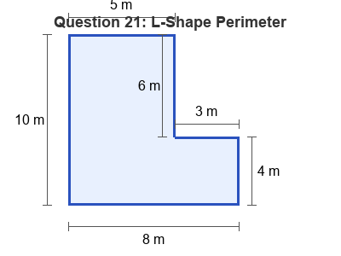
A. 28 metres B. 36 metres
C. 30 metres D. 40 metres
22. A farmer wants to fence a rectangular palm tree nursery that is 22 metres long and 18 metres wide. Fencing costs $8 per metre. What is the total cost of the fence?
A. $1280 B. $3168
C. $320 D. $640
23. A rectangular reserve has an area of 120 square metres. If the width of the reserve is 8 metres, what is the length?
A. 12 metres B. 112 metres
C. 30 metres D. 15 metres
24. What is the total area of the T-shaped compound zone shown in the diagram?
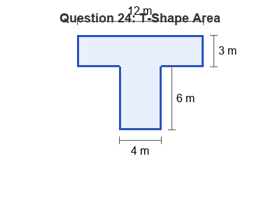
A. 72 square metres B. 48 square metres
C. 36 square metres D. 60 square metres
25. A square playground has a perimeter of 48 metres. What is the area of the playground?
A. 12 square metres B. 48 square metres
C. 96 square metres D. 144 square metres
26. A rectangular paddock is 20 metres long and has a perimeter of 60 metres. What is the area of the paddock?
A. 300 square metres B. 200 square metres
C. 800 square metres D. 400 square metres
27. What is the area of the remaining shape after the corner is removed?
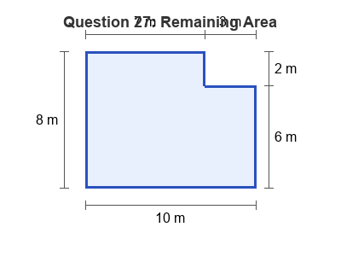
A. 86 square metres B. 80 square metres
C. 68 square metres D. 74 square metres
28. A rectangular classroom has an area of 72 square metres. If its length is 9 metres, what is its perimeter?
A. 34 metres B. 64 metres
C. 8 metres D. 17 metres
29. A square garden bed has an area of 100 square metres. If we double the length of its sides, what will the new area be?
A. 200 square metres B. 1000 square metres
C. 400 square metres D. 300 square metres
30. A rectangular courtyard measures 15 metres by 10 metres. A 1-metre wide brick path is built inside the courtyard, running all the way around the inner edge. What is the area of the brick path?
A. 150 square metres B. 104 square metres
C. 46 square metres D. 50 square metres

